28.60: a) Note that the Earth’s magnetic field exerts no force on wire B, since the current in wire B is parallel to the Earth’s magnetic field. Thus, for equilibrium, the remaining two forces that act on wire B must cancel. Assuming that the length of wire B is and that wire A carries a current we obtain
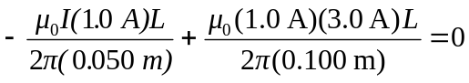
So
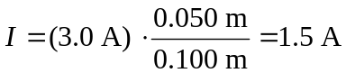
b) Note that the force on wire B that is generated by wire C is to the right. Thus, if the current in wire C is increased, wire B will slide to the right.

